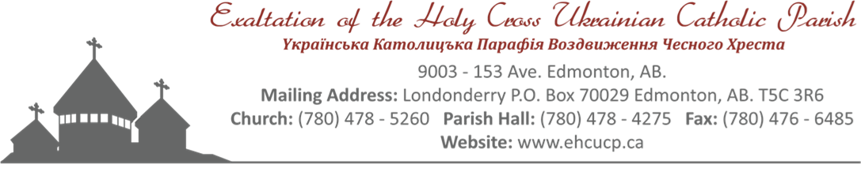
Holy Cross Ukrainian Catholic Parish
Funeral
Non-Member

After Prayer Service Fellowship
Funeral Dinner
Memorial Dinner
Contact: Cheryl: 780-456-2828

Effective June 8, 2022
All prices are subject to change without notice

NON-MEMBER – FUNERAL/MEMORIAL
Church Only $ 200.00
Hall Rental (half hall, lino only) $ 375.00
Hall Rental (full hall) $ 550.00
Use of Digital Projector $ 50.00
NOTE: Laptop/DVD Player/HDMI cable not provided

PRAYER SERVICE - FELLOWSHIP MENU $ 10.00 per person
Doughnuts, Sweet Loaf Breads, etc.
Coffee, Tea, and Juice

FUNERAL/MEMORIAL MENUS
Choice A - Sandwiches: $ 19.00 per person (children 8 and under no charge)
MENU:
Sandwiches (Cold Cuts, Egg, and Salmon)
Cheese Tray (assorted)
Pickles (Bread & Butter and Dill)
Various Pastries and Fruit Platter
Jell-O with Cool Whip
Coffee, Tea and Juice

Choice B – Cold Plate: $ 22.00 per person (children 8 and under no charge)
MENU:
Cold Cuts and Garlic Sausage
Potato Salad
Vegetable Platter
Cheese Tray (assorted)
Pickles (Bread & Butter, and Dill)
Buns and Butter
Various Pastries and Fruit Platter
Jell-O with Cool Whip
Coffee, Tea, and Juice

Choice C – Hot Meal: $ 31.00 per person (children 8 and under no charge)
MENU:
Choice of: Roast Beef and Horseradish OR Baked Chicken
Mashed Potatoes and Gravy
Salad (choice of Caesar, Coleslaw, or Tossed)
Vegetables
Pickles (Bread & Butter, and Dill)
Buns and Butter
Various Pastries and Fruit Platter
Jell-O with Cool Whip
Coffee, Tea and Juice

EXTRAS:
1. Lazy Cabbage Rolls - $ 3.50 per person
2. Extra Salad (Caesar, Coleslaw, or Tossed) - $ 5.50 per person
3. Cornmeal - $ 6.00 per person
4. Cheddar Perogies and Sour Cream - $ 6.25 per person
5. Sweet Cabbage Rolls - $ 6.25 per person
6. Chicken - $ 7.00 per person
7. Beef - $ 7.00 per person
8. Ham - $ 7.00 per person
9. Meatballs - $ 7.00 per person

