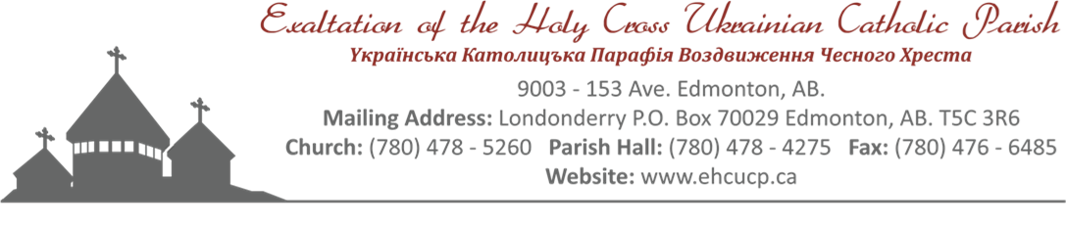
Holy Cross Ukrainian Catholic Parish
Funeral
Members Only

After Prayer Service Fellowship
Funeral Dinner
Memorial Dinner
Contact: Cheryl: 780-456-2828

Effective June 8, 2022
All prices are subject to change without notice

NOTE: To receive member rates the deceased person must have been a fully paid up member of Holy Cross Parish for past 20 months.
MEMBER – FUNERAL/MEMORIAL
Funeral Hall Rental No charge
Memorial Dinner Hall Rental (half hall, lino only) $ 250.00
Memorial Dinner Hall Rental (full hall) $ 450.00
Use of Digital Projector $ 25.00
NOTE: Laptop/DVD Player/HDMI cable not provided

PRAYER SERVICE - FELLOWSHIP MENU Charged for cost of groceries
Doughnuts, Sweet Loaf Breads, etc.
Coffee, Tea, and Juice

FUNERAL/MEMORIAL MENUS
Choice A - Sandwiches: $ 12.00 per person (children 8 and under no charge)
MENU:
Sandwiches (Cold Cuts, Egg, and Salmon)
Cheese Tray (assorted)
Pickles (Bread & Butter and Dill)
Various Pastries and Fruit Platter
Jell-O with Cool Whip
Coffee, Tea and Juice

Choice B - Cold Plate: $ 15.00 per person (children 8 and under no charge)
MENU:
Cold Cuts and Garlic Sausage
Potato Salad
Vegetable Platter
Cheese Tray (assorted)
Pickles (Bread & Butter, and Dill)
Buns and Butter
Various Pastries and Fruit Platter
Jell-O with Cool Whip
Coffee, Tea and Juice

Choice C - Hot Meal: $ 18.00 per person (children 8 and under no charge)
MENU:
Choice of: Roast Beef and Horseradish OR Baked Chicken
Mashed Potatoes and Gravy
Salad (choice of Caesar, Coleslaw, or Tossed)
Vegetables
Pickles (Bread & Butter, and Dill)
Buns and Butter
Various Pastries and Fruit Platter
Jell-O with Cool Whip
Coffee, Tea and Juice

EXTRAS:
1. Lazy Cabbage Rolls - $ 3.00 per person
2. Extra Salad (Caesar, Coleslaw, or Tossed) - $ 4.00 per person
3. Cornmeal - $ 4.00 per person
4. Cheddar Perogies and Sour Cream - $ 4.75 per person
5. Sweet Cabbage Rolls - $ 4.75 per person
6. Chicken - $ 5.00 per person
7. Beef - $ 5.00 per person
8. Ham - $ 5.00 per person
9. Meatballs - $ 5.00 per person

