Holy Cross Ukrainian Catholic Parish Funeral
Non Members

After Prayer Service Fellowship
Funeral Dinner
Memorial Dinner

Contact: Lasha: 780-540-0803
Effective July 6, 2018

NON MEMBER – FUNERAL
HALL RENTAL
Lino (Half Hall) $300.00
Lino and Carpet Area (Full Hall) $450.00
AFTER PRAYER SERVICE – FELLOWSHIP MENU

Doughnuts, sweet loaf breads etc. Coffee, Tea, and Juice $5.00 per person

FUNERAL/MEMORIAL MENU

SANDWICHES: - $12.00 per person – child 8 & under n/c
Sandwiches include:
Cold Cuts
Egg
Salmon
Cheese Tray
Pickles – Bread & Butter/Dill Pickles
Dessert – Pastries and Fruit Platter and Jello w c/w cool whip Coffee - Tea – Juice

HOT MEAL: $18.00 per person – child 8 & under n/c

MENU “A” MENU “B”
Roast Beef/Gravy/Horseradish Hot Roast Beef on an Bun
OR Mushrooms and Onions
Baked Chicken c/w gravy Potato Salad
Mashed Potatoes AND
Vegetables

MENU “A” AND “B”
ONE Salad – choice of Caesar or Coleslaw or Tossed …..extra salad $1.50 per person
Pickles – Bread and Butter and Dill
Buns/Butter

Dessert: Choice of Chocolate or Lemon Pudding Squares
and Jello c/w whipped cream
OR

Various Pastries and Fruit Platter and Jello w/c whipped cream
Coffee-Tea-Juice
EXTRAS:
1. Lazy Cabbage Rolls - $1.50 per person
2. Extra salad and/or cornmeal - $1.50 person for each choice
3. Cheddar perogy and/or Sweet Cabbage Rolls - $2.25 each per person for each choice
4. Extra meat selection meatballs.- $2.25 per person
5. Extra chicken, beef, pork, ham - $3.00 per person

NON MEMBER – FUNERAL
HALL RENTAL
Lino (Half Hall) $300.00
Lino and Carpet Area (Full Hall) $450.00

COLD PLATE: $15.00 Per person – Child 8 and under no charge

Menu

Potato Salad
One Salad Caesar or Tossed or Vegetable Platter – extra salad $1.50 per person
Cold Cuts and Sausage
Pickle Tray: Bread & Butter and Dill
Cheese Tray – assorted
Buns/Butter

Dessert: ONE choice of :

Chocolate or Lemon Pudding Squares and Jello c/w cool whip

OR

Various Pastries and Fruit Patter and Jello c/w cool whip
Coffee – Tea – Juice

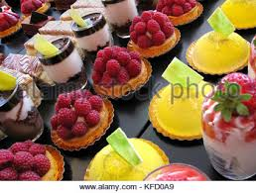

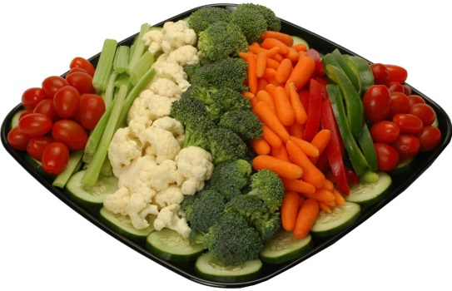

All prices are subject to change without notice

