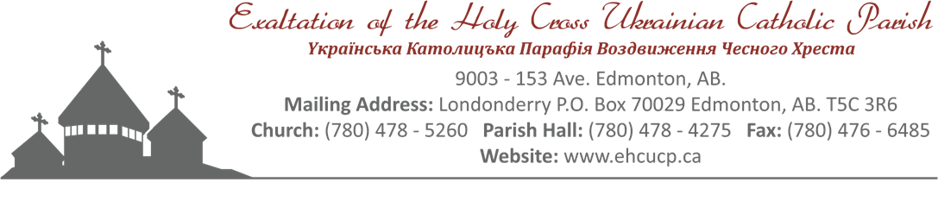

Holy Cross Ukrainian Catholic Parish Funeral
Members Only

After Prayer Service Fellowship
Funeral Dinner
Memorial Dinner
Contact: Lasha: 780-540-0803

Effective July 6, 2018
MEMBERS – FUNERAL – No Charge Hall Rental
MEMORIAL DINNER HALL RENTAL (Half Hall) $225.00 and Full $450.00
AFTER PRAYER SERVICE – FELLOWSHIP MENU
Doughnuts, sweet loaf breads etc. Coffee, Tea, and Juice….Charged for cost of groceries
FUNERAL/MEMORIAL MENU
SANDWICHES: - $9.00 per person – child 8 & under n/c
Sandwiches include:
Cold Cuts
Egg
Salmon
Cheese Tray
Pickles – Bread & Butter/Dill pickles
Dessert – Pastries and Jello w c/w cool whip and Fruit Platter
Coffee - Tea – Juice

HOT MEAL: $14.00 per person – child 8 & under n/c

MENU “A” MENU “B”
Roast Beef/Gravy/Horseradish Hot Roast Beef on a Bun
OR Mushrooms and Onions
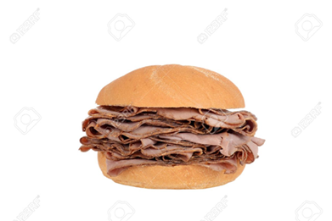
Baked Chicken c/w gravy Potato Salad
Mashed Potatoes AND
Vegetables

MENU “A” AND “B”
ONE Salad – choice of Caesar or Coleslaw or Tossed
extra salad $1.50 per person
Pickles – Bread and Butter and Dill
Buns/Butter

Dessert: Choice of Chocolate or Lemon Pudding Squares and Jello c/w whipped cream
OR
Various Pastries and Fruit Platter and Jello w/c whipped cream
Coffee-Tea-Juice

EXTRAS:
1. Lazy Cabbage Rolls – $1.50 per person
2. Extra salad and/or cornmeal - $1.50 person for each choice
3. Cheddar perogy and/or Sweet Cabbage Rolls - $2.25 each per person for each choice
4. Extra meat meatballs - $2.25 per person
5. Extra chicken, beef, ham and pork - $3.00 per person

MEMBER – FUNERAL
HALL RENTAL – NO CHARGE

COLD PLATE: $11.00 Per person – Child 8 and under no charge

Menu

Potato Salad
One Salad Caesar or Tossed OR Vegetable Platter and Dip – extra salad $1.50 per person
Cold Cuts and Sausage
Pickle Tray: Bread & Butter and Dill
Cheese Tray – assorted
Buns/Butter

Dessert:
ONE choice of Chocolate or Lemon Pudding Squares and Jello c/w cool whip

OR

Various Pastries and Fruit Patter and Jello c/w cool whip
Coffee – Tea – Juice

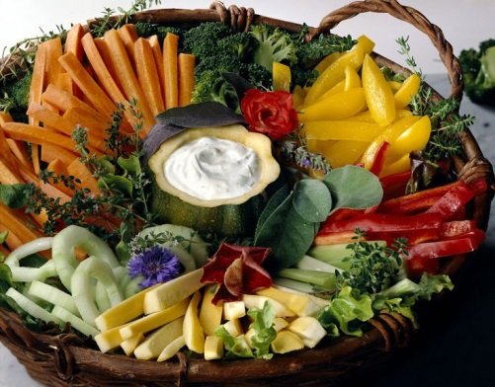

All prices are subject to change without notice

